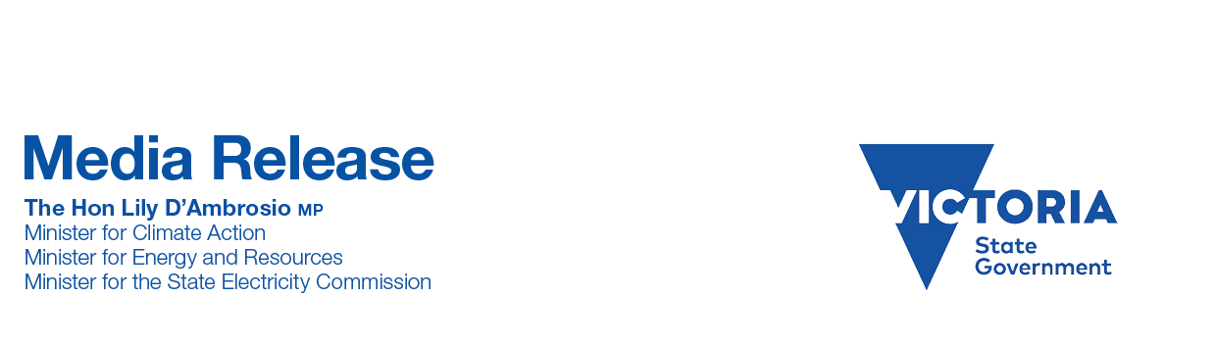
Wednesday, 27 May 2026
LOWER ENERGY PRICES FOR EMBEDDED NETWORKS
Labor is mandating lower energy prices for Victorian households and businesses in embedded networks.
Around 174,000 households and 20,000 small businesses in Victoria are in these private energy networks which include apartment blocks, retirement homes, caravan parks and shopping centres.
Many of them are paying higher prices, because they can’t choose their retailer or ‘shop around’ for a cheaper deal.
So, Labor will change the law to require energy companies to offer lower electricity and gas prices, including bundles services to these customers.
Indicative savings for electricity alone could be up to $250 per year for households and up to $600 per year for small business.
In 2019, Labor capped prices for embedded networks at the Victorian Default Offer (VDO). This announcement will push prices down even further, aligning them with the most competitive rates in the market.
This builds on Labor’s reforms to protect embedded network customers, including banning most new apartment-based networks unless they meet strict renewable energy standards.
We also strengthened consumer protections so people in embedded networks get fairer treatment, with clear rules on billing, hardship support and disconnections – bringing them in line with standard energy customers.
Labor is on the side of Victorians, putting household bills ahead of the profits of private energy companies.
The lower price will be set following consultation with industry and consumers, to commence on 1 July 2027.
Because of our record investment in renewable energy and energy efficiency upgrades, more than half a million Victorian households and small businesses will start saving on their energy bills from 1 July this year.
On average, that means savings of $84 for households and $241 for small businesses under the reduced Victorian Default Offer – which is $444 per year cheaper for households and $1299 for small business than the DMO equivalent in SA, NSW and QLD.
Jess Wilson’s Liberals will always look after their private, for-profit mates first, not Victorians.
While Labor is investing in the renewable energy needed to drive down power prices, Jess Wilson and the Nationals are stuck in the past, propping up ageing coal plants at the end of their life.
Quotes attributable to Minister for Energy and Resources Lily D’Ambrosio
“Labor puts people first and that means real action to make everyday life more affordable for Victorian families.”
“Jess Wilson supports privatisation, wants to scrap the SEC, and would let energy companies send your bills skyrocketing.”
Quote attributable to Member for Northern Metropolitan Enver Erdogan
“We’re making sure Victorian families get a better deal on their energy bills and keep more money in their pocket.”

