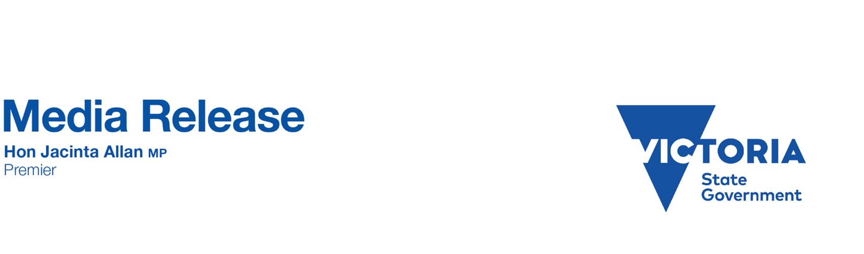
Sunday, 1 February 2026
BIG SWITCH IS ON – MORE THAN 1,200 NEW SERVICES LAUNCHED
The Allan Labor Government transformed our rail network with the Metro Tunnel.
Now it’s time for the Big Switch to make public transport faster and more reliable.
The Premier joined Minister for Public and Active Transport Gabrielle Williams at Parkville Station to launch it.
The Big Switch
Today is when the Metro Tunnel fully integrates into the rail network – but it’s far bigger than that.
From today, the public transport system in Victoria will be bigger, faster and more reliable than ever.
- Today, we launch more than 1,200 new weekly train services
- Today, we deliver a turn-up-and-go network for the Sunbury, Cranbourne and Pakenham lines – with all trains going through the Metro Tunnel
- Today, thousands of individual timetable changes occur at once across Victoria, including the first of 270 new bus timetables to better connect to Metro Tunnel services
- Today, we launch dozens of new regional services
- And today, the Frankston Line returns to the City Loop
During peaks on the Sunbury, Cranbourne and Pakenham lines, service frequency will be up to every three minutes between Dandenong and West Footscray.
Outside the peaks, trains will run at least every 10 minutes between the city and Watergardens from 6am to 9pm, and they will run at least every 10 minutes between the city and Dandenong from 6am to midnight.
The Werribee and Williamstown Lines will temporarily run directly to Flinders Street, before connecting with the Sandringham Line later in the year to form a new cross-city service.
Regional passengers will benefit from additional services: 18 on the Traralgon Line, 10 along the Seymour Line, and four on the Echuca Line.
New timetables and adding 1,200 more services will change a lot of people’s usual journeys.
It’ll take time getting used to – but it’s worth it to deliver a faster and more reliable public transport system.
The Big Switch is just the first installment of the new services that will be added to the network.
More frequent services across the network will come later year including on the Werribee, Sandringham, Craigieburn and Upfield Lines.
More than 800,000 passengers have visited the new Metro Tunnel stations since it opened in November.
The Metro Tunnel makes it easier for people to get to work, access healthcare and spend more time with families.
Never forget, the Liberals called the Metro Tunnel a “hoax”.
They consistently refused to fund it.
It’s now open and delivering more train services for Victorians.
For information, visit transport.vic.gov.au/news-and-resources/projects/metro-tunnel/more-ways-to-move
Quotes attributable to Premier Jacinta Allan
“In today’s world, time and money are tighter than ever. That’s why we’re making public transport faster and that’s why we made it free for kids.”
“More train services mean a better transport system, less time in traffic and more time at home.”
Quotes attributable to Minister for Public Transport and Active Transport Gabrielle Williams
“The Big Switch delivers better public transport services and more options for passengers and it’s just the start.”
“The changes today will take time for passengers to get used to, but it’s worth it for a bigger, better, faster system.”

